**COMP 7005**

**Computer Networks & Protocols**

*Assignment-02*

*Testing*

##### Anmol Mittal A01397754

##### February 9th, 2025

##### Course Reference Number (CRN): 92522

**Tests** 4

Test 01 4

Test 02 4

Test 03 4

Test 04 5

Test 05 5

Test 06 5

Test 07 6

Test 08 6

Test 09 7

Test 10 7

Test 11 8

Test 12 8

Test 13 9

Test 14 9

Test 15 10

Test 16 10

Test 17 11

|  |  |  |  |
| --- | --- | --- | --- |
| **Test** | **Expected** | **Actual** | **Screenshot** |
| IP is not proper length | fail | fail | Test 1 |
| IP segment out of range | fail | fail | Test 2 |
| IP have a char in it | fail | fail | Test 3 |
| Port number is put of range | fail | fail | Test 4 |
| Port number have a char in it | fail | fail | Test 5 |
| Port number have 0s in front (eg 0022) | fail | fail | Test 6 |
| Incorrect number of arguments | fail | fail | Test 7 |
| 2 consecutive dots in IP (eg 10..0.0.1) | fail | fail | Test 8 |
| Empty file name | fail | fail | Test 9 |
| Empty IP | fail | fail | Test 10 |
| Empty port | fail | fail | Test 11 |
| Empty key | fail | fail | Test 12 |
| IP ending with start or end with dot | fail | fail | Test 13 |
| Numbers in Key | fail | fail | Test 14 |
| Small line with ! | pass | pass | Test 15 |
| one line sentence | pass | pass | Test 16 |
| one letter file | pass | pass | Test 17 |
| Sending Numbers to Encrypt (Remained unchanged) | pass | pass | Test 18 |
| Sending Symbols to Encrypt (Remained unchanged) | pass | pass | Test 19 |
| combination of alphabets, number and symbols | pass | pass | Test 20 |
| Upper case alphabets | pass | pass | Test 21 |
| Lower Case alphabets | pass | pass | Test 22 |
| Upper Case + Lower Case | pass | pass | Test 23 |
| Empty File | fail | fail | Test 24 |
| File with Just Spaces | pass | pass | Test 25 |
| ASCII Code (Remain Unchange) | pass | pass | Test 26 |
| Long File | pass | pass | Test 27 |
| Not a Text file but HML | pass | pass | Test 28 |

# **Tests**

## Test 01

## Test 02

## Test 03

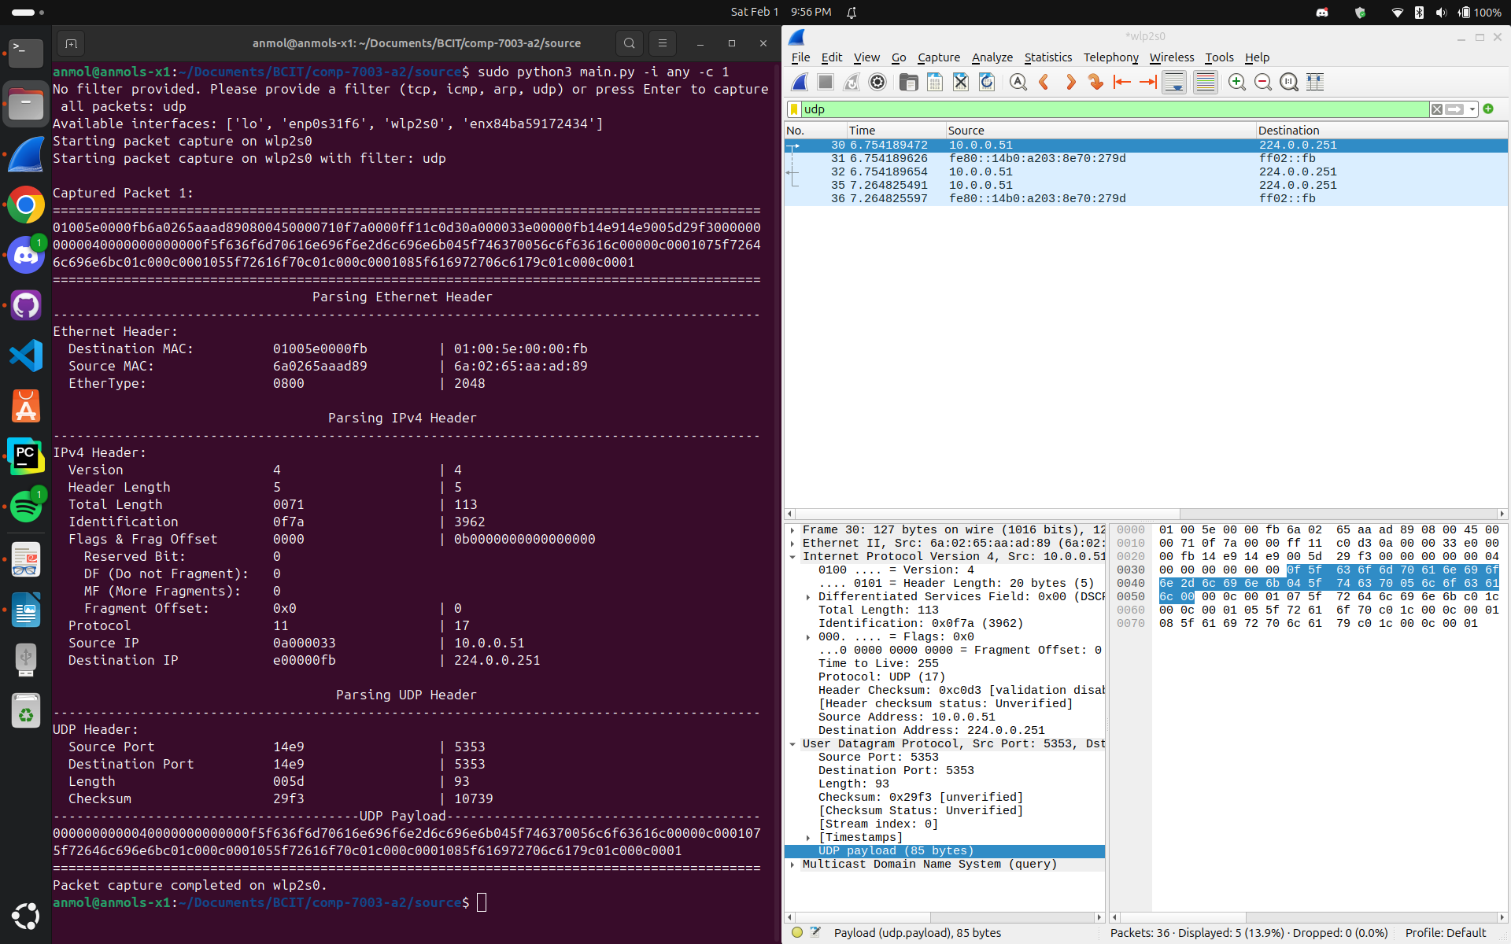

## Test 04

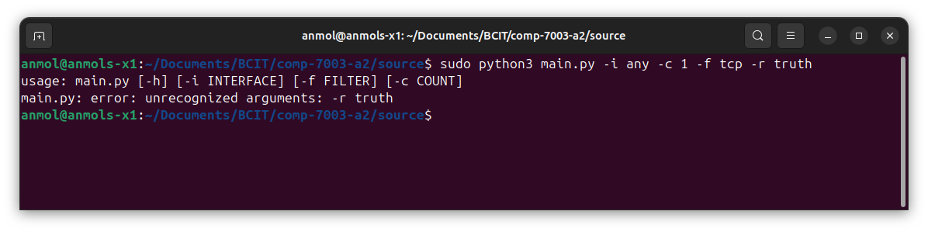

## Test 05

## Test 06

## Test 07

## Test 08

## Test 09

## Test 10

## Test 11

## Test 12

## Test 13

## Test 14

## Test 15

## Test 16

## Test 17

